Contractor Connect Skill Evaluation Sheet
Candidate Name: | Abdul Kareem |  | 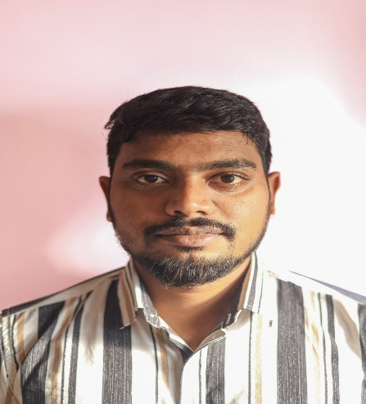
Total Experience: | 6 years
Relevant Experience: | 3.5
Notice Period: | 30 days Current Location
MSP Input |  | Supplier Input
Candidate Skills | Mandatory/ Optional | Name of Projects in which  the skills were used  (Add rows if necessary) | No: of years worked  in each Project | Description of work done  using the skill
Primary Skill 1: Snowflake | M | Data analysis for Insurance domain | 1 year | maintaining the data and collecting it data source from cloud and writing queries to fetch the relevant data.
Primary Skill 2: SQL | M | Telecommunication Domain | 1.5 year | Writng queries to fetch the data which could be utilized for data visualization
Primary Skill 3: Power BI | M | Telecommunication/ Insuarance domain Project | 3.5 year | Building reports and dashboards in power BI
Secondary Skill 1: python | O | Logistics Domain project | 7 months | Exploratory data analysis for a logistcs based data set to build a machine learning model on top of it
Secondary Skill 2: RPA | O | MoovKart | 5 months | webscraping the data from different portals using the automation
Secondary Skill 3: AWS_S3 | O | Data analysis for Insurance domain | 1 year | using the AWS_s3 bucket to integrate it with snowflake using snow pipe for auto ingestion of the data into database

Abdul Kareem
Data Analyst
Phone: +91-9110524973
Email: kareemab1402@gmail.com

SKILLS
Programming Skills: Python
Database: SQL Server, MYSQL
Cloud: Google Cloud Platform (GCP), Snowflake
Business Intelligence: Power BI
RPA: IBM RPA, UiPath
Miscellaneous: MS EXCEL (VLOOKUP, HLOOKUP, XLOOKUP), MS WORD, MS POWER POINT

EXPERIENCE

NerdPine Solutions LLC, Hyderabad- Data Analyst
NOV 2021 - PRESENT
Project 1: Data Analysis Client: Logistics Domain Role: Data Analyst
Environment: Python, EDA, Machine Learning
Description: Inland Looking for Route Forecasting for coming Weeks / Months based on Past/ Previou Actual data, this process must use Python and ﬁgure out issues.

Roles and Responsibilities:
- Data exploration and examining the data to identify the patterns, trends and anomalies.
- Data cleaning and addressing issues with the data, such as missing values, duplicates or outliers.
- Created visual representation of the data into graphs and charts.
- Performed statistical analysis on the data to identify correlation, distributions and other trends.
- Created a statistical model to help understand the relationship between diﬀerent variables in the data.
- Presented the ﬁndings of the analysis in a clear and concise way using reports and presentations that highlighted the most important insights.

Project 2: Process Mining Analysis Client: Insurance Procurement Domain Role: Data Analyst
Environment: Python, EDA, MYSQL, Snowﬂake, Power BI and IBM RPA
Description: Description: The project is about improving the discovery, validation and process workﬂow in the ﬁnancial sector of the industry. Using the cutting-edge technology tools like SQL, Python, Snowflake, Power BI and IBM RPA

Roles and Responsibilities:
- Data extraction from the MYSQL for the process has been done in the company like PO data and Invoice Reconciliation data.
- Data cleaning and addressing issues with the data, such as missing values, duplicates or outliers.
- Data transformation using Power BI making it as an event log data from the data which we gathered from the diﬀerent data sources.
- Created visual representation of the data into graphs and charts.
- Performed statistical analysis on the data to identify correlation, distributions and other trends.
- Finding the behavioral pattern of the process using data modeling.
- Presented the ﬁndings of the analysis in a clear and concise way using reports and dashboard that highlighted the most important insights.

Quadgen Wireless Solutions, Bangalore- Data Analyst
JUL 2019 - DEC 2020
Project: Bharat Net
Client: APSFL Role: Data Analyst
Environment: Power BI, SQL, Bitcomm
Description: Bharat net is a project of Government of India which was funded by Universal Service Obligation fund, Department of telecommunications. The idea of the project is to give internet connectivity to rural India for the betterment of society.

Roles and Responsibilities:
- Data collection and preparation from various data sources such as internal databases, Bitcomm Tool, Excel etc.
- Data cleaning, transforming and integrating data from diﬀerent data sources to ensure its accuracy and completeness.
- Created dashboards and reports that provide insights into KPIs for customer satisfaction and network performances.
- Created dashboards and reports which provide actionable insights that have been used to improve business performance.
- Created compelling visualizations that help to communicate complex data in a clear and concise manner.

- Worked closely with stakeholders across the organization, Including executive managers, project director

Medac Enterprises, Calicut - Electrical Design Engineer
JAN 2018 - JUN 2019
Project: Hafar al batin building
Client: Lu Lu mall
Role: Electrical Design Engineer
Environment: Excel, AutoCAD. Electrical Design
Description: To design the Electrical and security layouts for the building and the infrastructure by maintaining the Arab security guidelines,

Roles and Responsibilities:
- To deﬁne the functional formulas in the excel to calculate the ﬂux quantities.
- To the design the layout in the AutoCAD as per the civil construction guidelines.

Johnson Controls Inc, Bangalore- BMS Operator
JAN 2017 - DEC 2017
Project 1: Building Maintenance Systems
Client: Accenture
Role: BMS Operator
Environment: Fire Alarm Systems, Access Control systems, CCTV
Description: To maintain security and safety systems which are installed in the Accenture buildings.

Roles and Responsibilities:
- To do the preventive maintenance check to the systems which are involved in Accenture buildings.
- Fire alarm systems perform the checklist activities.
- To check security level access for the employees using ACS.
- Controlling the DVR’s of CCTV.

EDUCATION

Gudlavalleru Engineering College - B. Tech (E.E.E.)
Sept 2012 - APR-2016
Narayana Junior College - Intermediate
JUN 2009 - APR-2011

Noori Model High School - SSC
JUN 2008 - MAR-2009

Personal Projects
- Zomato Dataset Analysis (Performing EDA).
- Credit card risk Analysis (Built a predictive model to identify the risk )

Languages
- English
- Telugu
- Hindi

